Q4)Ansible

1)create inventory file

2)create playbook update_packages.yml

3)Test connection

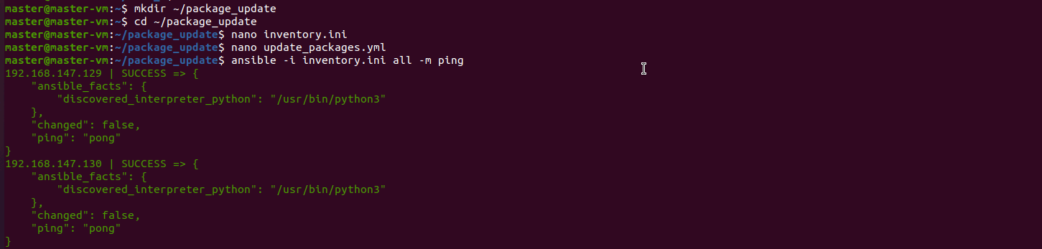

4)Run the playbook

5)verifying on remote machines

